Haskell Set 8
1) Without explicitly taking parameters, write a function that determines if any given value is positive or not.
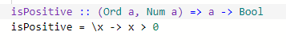
2) Rewrite the even function but take in no parameters directly, although a parameter will be coming in.
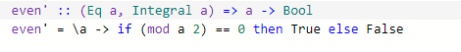
3) Using no list comprehension or recursion, get all of the first items out of a list of tuples.
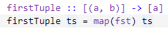
4) Without explicitly taking parameters, write a function that determines the first ? number of squares, where ? is the
parameter. Use maps instead of list comprehension.
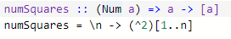
5) Reverse a list of tuples (fst->snd, snd->fst). Can you do it without list comprehension?
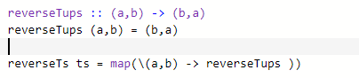
6) After reading about filters, (apologizing for the really poor taste example in the chapter), where have you been using
filters in Haskell already without explicity calling the word filter?
There is also filter in list comprehensions.

7) IMDB has a bunch of movies with ratings in a list of tuples, [Title, Rating]. Without using list comprehension, instead
use maps/filters/zip/whatever, find the number of movies which are rated above an 8.
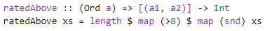
8) Using a lambda and a filter, calculate all possible triangles with integer side lengths from x to y. Yay for resuing old
questions. Reduce, reuse, and recycle.
possibleTrangs x y = filter(\(a,b,c) (a + b > c) && (c + a > b) && (c + b > a)) [(a,b,c) | (a,b,c) <- [x..y]]

9) Skip ahead and learn how to get input. Write a segment of code which has a user type in their age and determines if
they are allowed to vote or not yet.
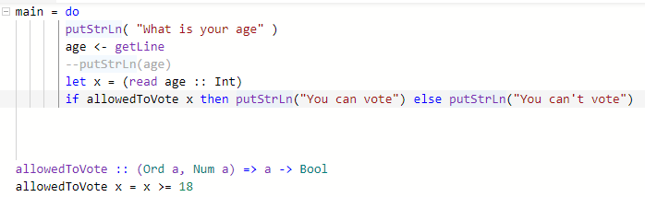
10) Have a user type in three numbers, start, stop, and delta, display all numbers from start to stop with delta skipping
amount - unless the delta won't lead towards the stop, in which case display an error about that sequence not working.

